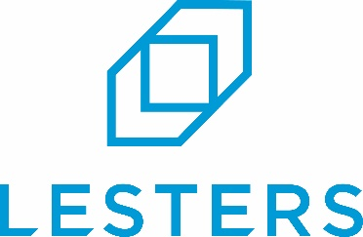

At Lesters we’re a family-owned business with forty years of heritage. We’re friendly, responsive, and have grown by being a true business partner to our clients. We have big ambitions. We’ve invested heavily in facilities, technology and people to create improved capability, capacity and efficiency. We’re on an exciting journey to shake up the industry and we want to take you with us.
JOB SUMMARY

The Role: Production Team Leader – Nights

Lesters, the large packaging specialists, are looking for a Team Leader for our Nightshift to take charge of ensuring operations run smoothly, efficiently, and to the highest standards.

Key Duties

- Supervise and lead the nightshift crew, ensuring operations run smoothly.
- Proactively plan the next three jobs to ensure readiness and minimise downtime.
- Resolve running issues promptly.
- Operate and train others on machinery, material handling, and pallet stacking per job specs.
- Monitor job quality, resolve issues, and prevent non-conformance.
- Develop and share procedures, troubleshooting tips, and improvement ideas.
- Log set/run issues and suggestions to support continuous improvement.
- Serve as the main link between the team and the Company—share feedback, updates, and concerns.
- Provide ongoing training and coaching to upskill team members.
- Communicate Company updates and deliver toolbox talks from H&S and HR.
- Support team morale and report any concerns appropriately.
- Ensure completion of basic maintenance tasks via SPOCS (e.g., cleaning, greasing).

Our Ideal Candidate
The ideal candidate will have sufficient experience in a similar role with previous experience of working within the cardboard industry.

They will also:
- Be a team player
- Be willing and motivated to continuously strive to improve.
- Have a good work ethic
- Be a punctual and reliable individual, who is flexible, willing to learn and embrace new skills.

What is on offer?
- Competitive rates of pay, nightshift allowance (per shift) and quarterly bonus for excellence
- Working hours will be Monday to Thursday, 6pm to 6am
- Shift allowance, quarterly and annual bonus and overtime rates available
- Workplace pension scheme.
- Holidays: 28 days per year including bank holidays with access to the latest app based HR Portal making booking time off simple and accessible.
- Benefits to include medical cash plans, 24/7 employee assistance programme.
- Quality, branded uniform provided, so staff look and feel part of the team.
- Clear and open management structure, good staff facilities, ongoing investment in people and plant.
- Training and development open to all.
- Location: Mount Road Burntwood, Staffordshire, WS7 0AJ.

Applications

If you’re always thinking “What’s next?” rather than “That’s it.” and if you want to become an integral part of a forward-thinking ambitious organisation, we’d love to hear from you.

To apply, email your CV or complete our application form, which is available to download, to our HR Manager by clicking ‘to apply’

We’re Lesters, the large packaging specialists, and we deliver more.

