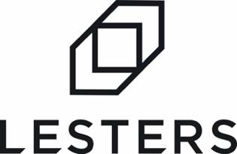

At Lesters we’re a family-owned business with forty years of heritage. We’re friendly, responsive, and have grown by being a true business partner to our clients. We have big ambitions.

We continue to invest in the best people, manufacturing facilities & technology to create unrivalled capability, capacity and efficiency. We’re on an exciting journey to shake up the industry and we want to take you with us.

JOB SUMMARY

The Role: Estimator/Commercial Analyst - Assistant.

The successful candidate will be working alongside the management, commercial & sales teams providing quotations directly to our large customer and prospect base. This is a key role in a fast paced, dynamic market. As such a high level of estimating knowledge and experience in the corrugated industry is desirable, however a candidate with transferable skills will be given all the necessary training that maybe required.

Key Duties
- Creating specifications
- Reviewing / adding costs where necessary
- Working within set tolerances of yield and margin
- Understanding and amending machine routings
- Supporting & co-ordinating responses of tender submissions
- Requesting quotations from suppliers
- Communicating with customers regarding their requirements
- Reviewing commercial returns across the market sectors.
- Working with the sales & technical teams to create value for Lesters and our clients.

About You
- Previous experience in a role of issuing quotations and pricing products/services.
- Organised and with great attention to detail.
- Strong numeracy skills.
- Strong IT literacy with solid working knowledge of MS Excel
- Comfortable working in a fast-paced environment
- A team player with effective communication skills
- An understanding of pricing systems would be beneficial

What is on offer?
- Competitive salary and benefits
- Potential for Hybrid working
- Workplace pension scheme
- Holidays: Minimum of 28 days per year including bank holidays, with access to the latest app-based software making booking time off simple and accessible and enhanced with service.
- Quality, professional Lesters branded clothing provided
- Clear and open management structure, great staff facilities, ongoing investment in people and plant.
- A fantastic opportunity to join a dynamic, fast growing business.

Applications

If you’re always thinking “What’s next?” rather than “That’s it.” and if you want to become an integral part of a forward-thinking ambitious organisation, we’d love to hear from you. Simply email your CV to jo@lesterspackaging.co.uk or apply online at www.lesterspackaging.co.uk/careers

