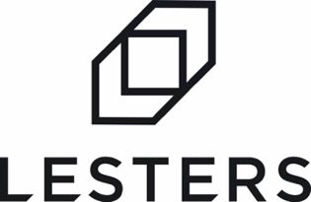

At Lesters we’re a family-owned business with forty years of heritage. We’re friendly, responsive, and have grown by being a true business partner to our clients. We have big ambitions. We’ve invested heavily in facilities, technology and people to create improved capability, capacity and efficiency. We’re on an exciting journey to shake up the industry and we want to take you with us.
JOB SUMMARY

The Role: Estimator

The successful candidate will support the management and sales teams by providing accurate and timely quotations directly to our large customer and prospect base. This is a key role in the business and as such a high level of estimating knowledge and experience in the corrugated industry is essential.

Key Duties
- Creating specifications
- Correcting/adding costs where necessary
- Working within set tolerances of yield and margin
- Understanding and amending routings
- Raising of tenders
- Requesting quotations from suppliers
- Communicating with customers regarding their requirements
- Examining data to ensure the minimum of job duplication

Our Ideal Candidate
Our ideal candidate will have extensive experience within the estimating function of a large packaging organisation, have a clear understanding of FEFCO codes and be able to advise the customer on what best suits their needs, and be confident enough to send quotes directly to the customer. Experience of the SPOCS management system would be an advantage

They will also:
- Be a team player
- Be commercially minded
- Be willing and motivated to continuously strive to improve.
- Have a good work ethic
- Be a punctual and reliable individual, who is flexible, willing to learn and embrace new skills.

What is on offer?
- Competitive salary
- Workplace pension scheme
- Holidays: 28 days per year including bank holidays, with access to the latest app based software making booking time off simple and accessible
- Quality, professional Lesters clothing provided
- Clear and open management structure, good staff facilities, ongoing investment in people and plant

Applications

If you’re always thinking “What’s next?” rather than “That’s it.” and if you want to become an integral part of a forward-thinking ambitious organisation, we’d love to hear from you.

To apply, visit www.lesterspackaging.co.uk/careers and complete our application form or email your CV to our HR Manager jo@lesterspackaging.co.uk

We’re Lesters, the large packaging specialists, and we deliver more.

