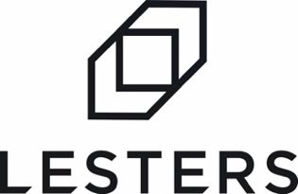

At Lesters we’re a family-owned business with forty years of heritage. We’re friendly, responsive, and have grown by being a true business partner to our clients. We have big ambitions. We’ve invested heavily in facilities, technology and people to create improved capability, capacity and efficiency. We’re on an exciting journey to shake up the industry and we want to take you with us.
JOB SUMMARY

The Role: Class 1 and 2 HGV Driver (Category C+E and Category C)

The successful candidate will represent our cutting-edge production facility in a front-line role, making sure our reputation for being the best includes our drivers. Candidates must have a Class 1 License, Driver CPC and experience in driving an Artic HGV.

Key Duties
- Driving our new, state of the art HGV and / or Artic HGV to make deliveries.
- Delivering on time, but always professionally.
- Taking ownership for your runs and being efficient.
- Carrying out driver checks before you start your engine.
- Helping load or unload vehicles as required.
- Adhering to all applicable driving regulations.
- Any other duties that are within your capabilities and relevant to the role.

Our Ideal Candidate
The ideal candidate will:

- Be a team player
- Be willing and motivated to continuously strive to improve.
- Have a good work ethic
- Be a punctual and reliable individual, who is flexible to the needs of the role.

What is on offer?
- Working hours will be 50 hours per week, Monday to Friday.
- Competitive pay
- Workplace pension scheme.
- Holidays: 28 days per year including bank holidays, with access to the latest app based software making booking time off simple and accessible.
- Quality, free uniform provided, so staff look and feel part of the team.
- Clear and open management structure, good staff facilities, ongoing investment in people and plant.
- Training and development open to all.
- Location: Mount Road Burntwood, Staffordshire. WS7 0AJ.

Applications
If you’re always thinking “What’s next?” rather than “That’s it.” and if you want to become an integral part of a forward-thinking ambitious organisation, we’d love to hear from you.

To apply, email your CV or complete our application form, which is available to download, to our HR Manager by clicking ‘to apply’

We’re Lesters, the large packaging specialists, and we deliver more

